Project Planning Phase

SPRINT-3

|  |  |
| --- | --- |
| Date | 8 November 2022 |
| Team ID | IBMSI2022004167 |
| Project Name | IOT BASED SAFETY GADGET FOR CHILDMONITORINGAND NOTIFICATION |

USN1:Asa user I need to enroll the cloud registration

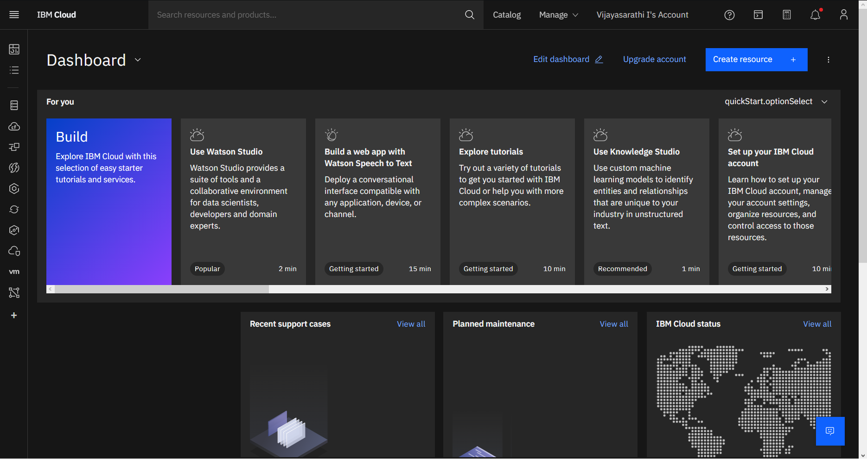

USN2: After creating cloud account launch IBM Watson IOT platform by acessing cloud account

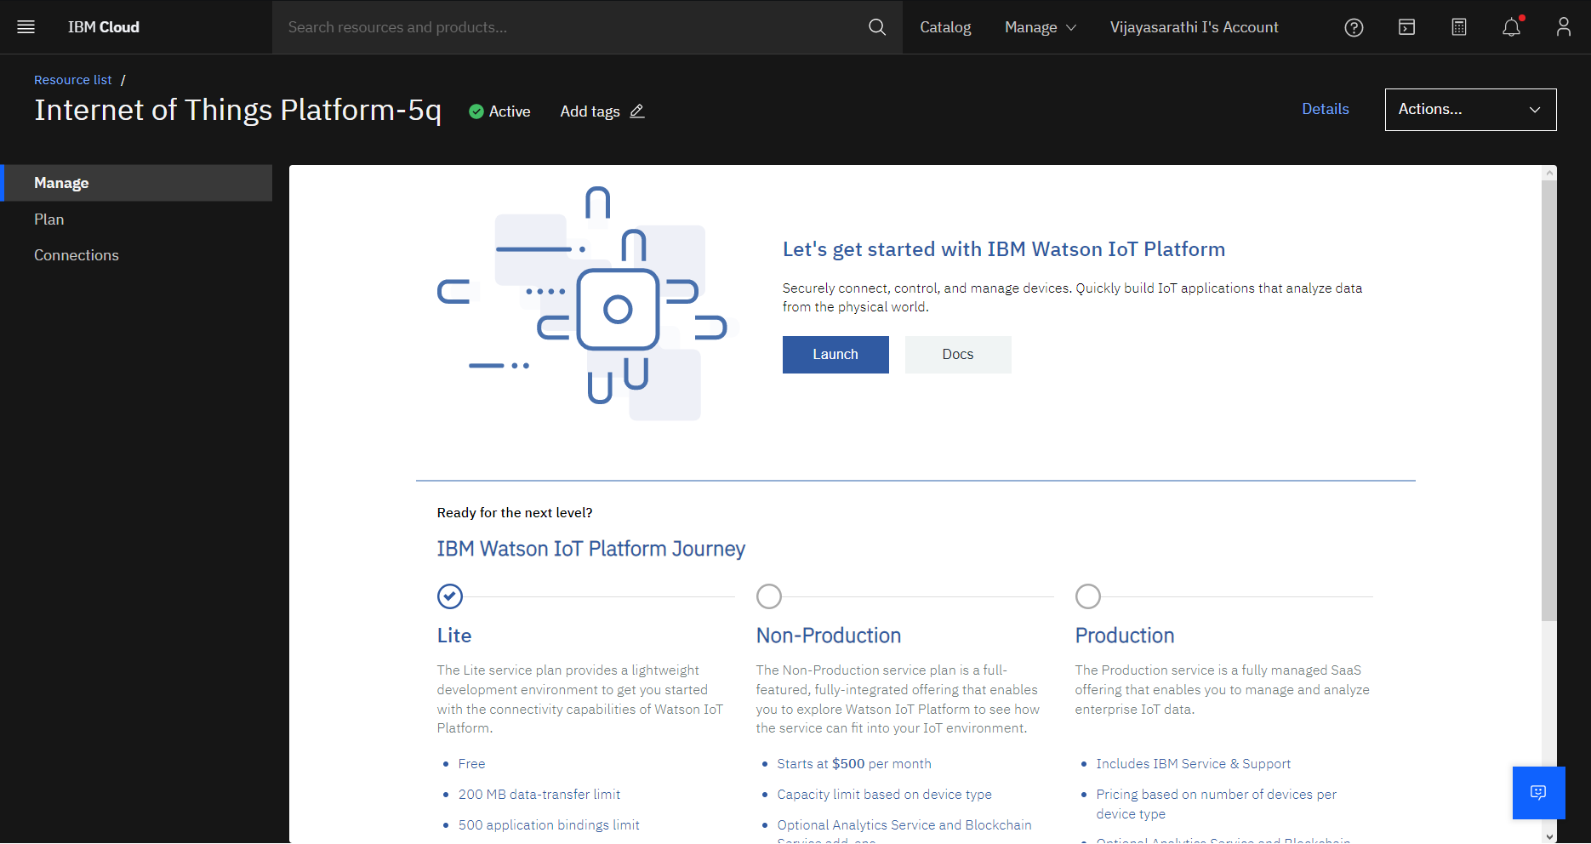

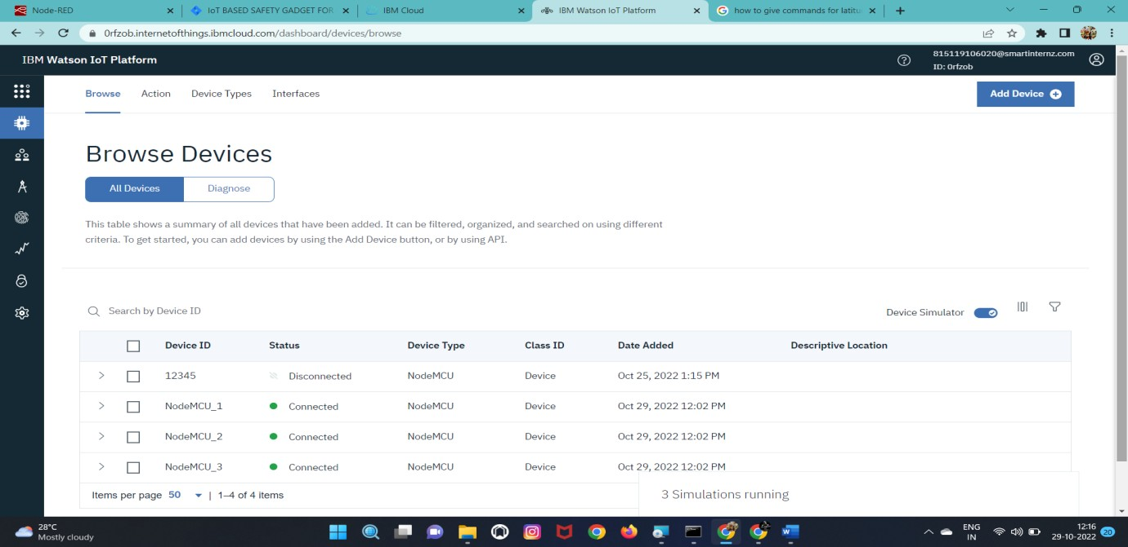USN3: Create the node in IBM Watson platform

USN4:AfterCreatingnodegetdeviceTypeandid

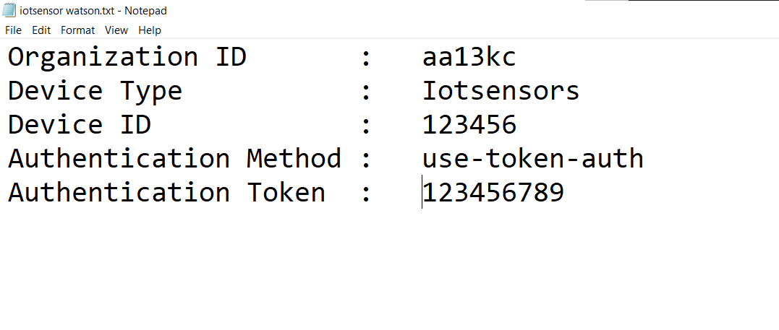

USN6: Simulate the node created

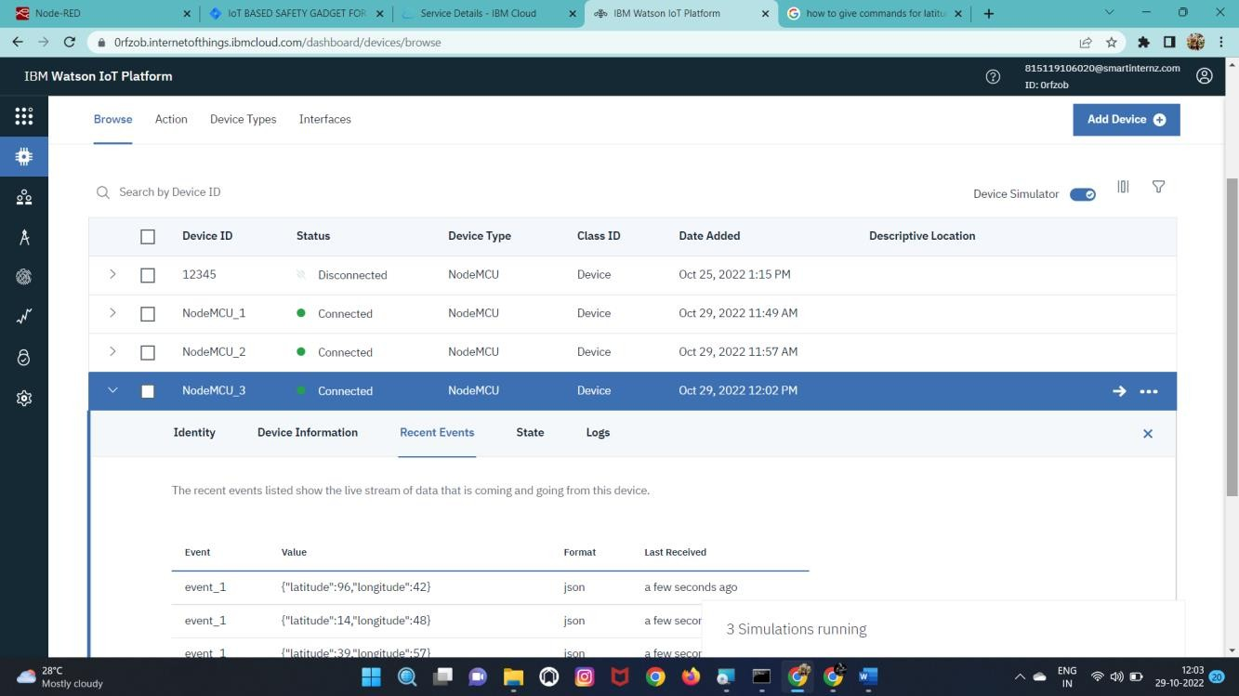

# BURNDOWNCHART:

# 

# VELOCITYCHART:

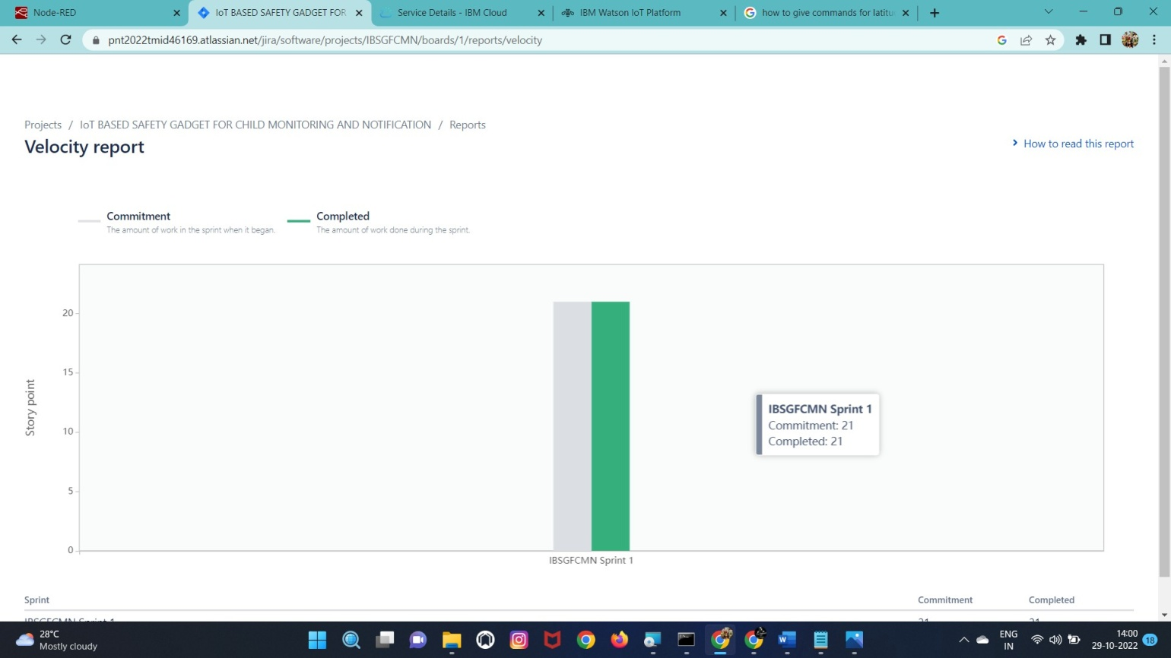

# ROADMAP:

